St. Mark Antiochian Orthodox Church
Antiochian Orthodox Christian Archdiocese, Diocese of the West
17840 Sky Park Circle, Irvine CA 92614 (949) 851-8933
Church Office Hours: M-F, 10:00 am – 3:30 pm
Website: www.st-mark-church.org

Archpriest Michael Laffoon, Priest Patrick Irish

Protodeacon George Moubayed, Dn. Nicholas Mamey, Sub Deacon Athanasius Fakhouri

Choir Director Barbara Scholl

Chanters: Jacob Bahbah, Mark Ellis, Theresa Joubran,

Karim Youssef

Church Office Secretary: Lydia Wakileh
Teen Advisor: Fatin Fakhouri
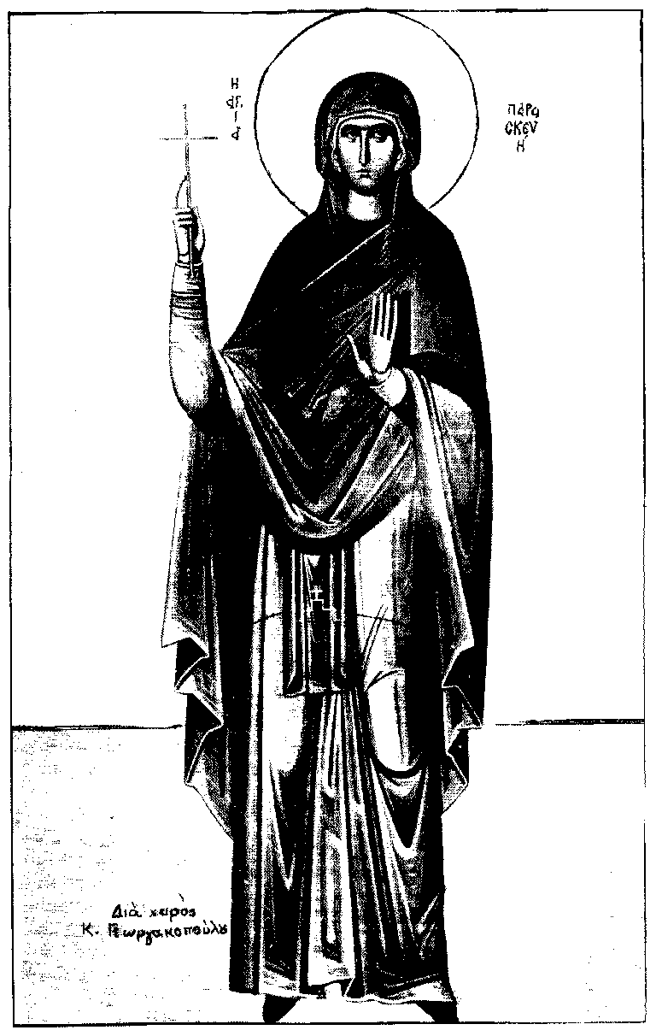
July 26, 2020
7th Sunday After Pentecost
The Holy Righteous Martyr Paraskeva of Rome
Hieromartyrs Hermolaus, Hermippus, and Hermocrates of Nicomedia; Venerable Gerontios, first settler of St. Anne skete on Athos; Moses the Hungarian; Sabbas III, archbishop of Serbia;
Priest Jacob Netsvetov, enlightener of the peoples of Alaska
HYMNS AFTER THE LITTLE ENTRANCE

All: Troparion for the Resurrection, in the Sixth Tone: When Mary stood at thy grave looking for thy sacred Body, angelic powers shone above thy revered tomb, and the soldiers who were to keep guard became as dead men. Thou led Hades captive and wast not tempted thereby; Thou didst meet the Virgin and didst give life to the world; O thou Who art risen from the dead, O Lord, glory to Thee.
Troparion of St. Paraskeva in the First Tone: Showing a diligence befitting thy calling, O namesake of preparedness, thou hast gained, as thy dwelling, a faith worthy of thy name, O prize-winning Paraskeva. Hence, thou pourest forth healings and intercedest for our souls.
All: Troparion to St. Mark in the Fourth Tone: From thy childhood the light of truth enlightened thee, O Mark, and thou didst love the labor of Christ the Savior. Wherefore thou didst follow Peter with zeal and didst serve Paul as a fellow laborer and didst enlighten the world with thy holy Gospel.
Kontakion of the Theotokos in the Second Tone: O undisputed intercessor of Christians, the mediatrix unrejected by the Creator, turn not away from the voice of our petitions, though we be sinners. Come to us in times, who cry to thee in faith, with assistance; for thou art good. Hasten to us with intercessions, O Theotokos, who dost ever intercede for those who honor thee.
+ + + + + + + + + + + + + + + + + + + + + + + + + + + + + + + + + + + + + + + +
Prokeimenon: God is wondrous in His saints. Bless God in the congregations.
The Reading from the Epistle of St. Paul to the Galatians. (3:23-4:5)
Brethren, before faith came, we were confined under the Law, kept under restraint until faith should be revealed. So that the Law was our custodian until Christ came, that we might be justified by faith. But now that faith has come, we are no longer under a custodian; for in Christ Jesus you are all sons of God, through faith. For as many of you as were baptized into Christ have put on Christ. There is neither Jew nor Greek, there is neither slave nor free, there is neither male nor female; for you are all one in Christ Jesus. And if you are Christ’s, then you are Abraham’s offspring, heirs according to promise. I mean that the heir, as long as he is a child, is no better than a slave, though he is the owner of all the estate; but he is under guardians and trustees until the date set by the father. So with us; when we were children, we were slaves to the elemental spirits of the universe. But when the time had fully come, God sent forth His Son, to redeem those who were under the Law, so that we might receive adoption as sons.

Alleluia Verse (Psalm 39:1, 2) I waited patiently for the Lord. He set my feet upon a rock.
Reading from the gospel according to St Matthew (9:27-35)
At that time, when Jesus was passing by, two blind men followed him, crying aloud, "Have mercy on us, Son of David." When he entered the house, the blind men came to him; and Jesus said to them, "Do you believe that I am able to do this?" They said to him, "Yes, Lord." Then he touched their eyes, saying, "According to your faith be it done to you." And their eyes were opened. And Jesus sternly charged them, "See that no one knows it." But they went away and spread his fame through all that district.
As they were going away, behold, a dumb demoniac was brought to him. And when the demon had been cast out, the dumb man spoke; and the crowds marveled, saying, "Never was anything like this seen in Israel." But the Pharisees said, "He casts out demons by the prince of demons."
And Jesus went about all the cities and villages, teaching in their synagogues and preaching the gospel of the kingdom, and healing every disease and every infirmity of the people.
+ + + + + + + + + + + + + + + + + + + + + + + + + + + + + + + + + + + + + + + +
Holy oblations are given today by Lilian Kassicieh for the souls of her
husband Shafik departed this life 15 years, her brother Jalal 7 years, and for the health and salvation of her family, Hani and Nawal, Maher and Rula, Michael, and Mark, by Sara Fortuna and family for the soul of her father Saba Saba 40 days memorial, and by Nuha Qushair, also for the soul of Saba Saba, and by Mary Dibs and Barbara Scholl and their families for the soul of George Dibs.

Until further notice, there is no Coffee Hour.

Please remember in your prayers: Eleanor Wackeen, Jamal El-Sayegh, Tarek Fakhouri, Adele Bahbah, Paul Qaqundah, Theresa Joubran, Gloria Mamey and the suffering people of Syria, Iraq, Lebanon, Egypt, Libya, Ethiopia, Somalia, Palestine, Venezuela, Ukraine, and all people afflicted by violence and disease, especially those affected by the Coronavirus.
+ + + + + + + + + + + + + + + + + + + + + + + + + + + + + + + + + + + + + + + +
Good Samaritan Fund
Several years ago, St. Mark Church established a fund for assisting those in need, both within our parish and in the general community. From time to time we ask for contributions to the Good Samaritan Fund, and this is one of those times. If you are in need of assistance or you are aware of someone in our parish that needs financial assistance, please speak with Fr. Michael.

Today
Please remember that even in the midst of this difficult period, the expenses of the parish continue. It is important that we send in our donations and pledges via U.S. mail, or if you prefer to pay by credit card call the Church Office to set this up. We are working to keep our expenditures as low as possible until things return to a more normal state.
This Week
Wednesday July 22, 6:00 p.m. Vespers
Saturday July 25, 4:00 p.m. Vespers

Quote from the Saints
All Who truly believe in Him and cleave to Him with all their soul are changed into His image by the power of His resurrection.
St. Theophan the Recluse
Holy Martyr Paraskeve of Rome (July 26)
Saint Paraskeve, who was from a certain village near Rome, was born to pious parents, Agatho and Politia. Since she was born on a Friday (in Greek, Paraskeve), she was given this name, which means "preparation" or "preparedness" (compare Matt. 27:62, Mark 15:42, Luke 23:54, and John 19:31, where 'Friday' is called "the day of the preparation"). From childhood she was instructed in the sacred letters and devoted herself to the study of the divine Scriptures, while leading a monastic life and guiding many to the Faith of Christ. During the reign of the Emperor Antoninus Pius, she was apprehended because she was a Christian and was urged to worship the idols, but she answered with the words of Jeremias: "Let the gods that have not made heaven and the earth perish from off the earth" (Jer. 10:11). Because of this she endured exceedingly painful torments, and was beheaded in the year 140. The faithful pray to her for the healing of eye ailments.
From our Council Chairwoman

Dear St. Mark Parishioners,

I hope that you and your family are doing well. With the resurgence of the COVID-19, I wanted to remind everyone that your health and safety are of upmost importance to the Parish Council. It has been brought to my attention that a few of our parishioners have tested positive for COVID-19. Our thoughts and prayers are with them for a speedy recovery. If you believe that you might have been exposed to the virus please get tested or self quarantine.
According to directives from His Eminence Metropolitan JOSEPH, we are able to welcome back the faithful up to 25% of our seating capacity. Please sign up in order to attend Divine Liturgy at https://www.signupgenius.com/go/904044cabab29a4ff2-sunday. Services will continue to be live-streamed so that the faithful at home may still join in prayer.
If you or any member of your household are sick, have a fever, or have been exposed to COVID-19 in the last 14 days, please stay home. If you know that you have been exposed to someone who recently tested positive for COVID-19 and you have not been tested we kindly ask that, for the sake of our Saint Mark’s parishioners, you refrain from attending services for a period of 14 days and/or confirm that you recently tested negative for COVID-19.
If you and/or any member of your household who have attended divine services test positive for COVID-19, please contact the church immediately.
*The wearing of protective masks is highly recommended when you are visiting our parish*
The above measures are necessary if we are to come together for holy services in a responsible and careful way, recognizing the highly contagious nature of COVID-19. This virus has claimed the lives of thousands of people around the world and gravely sickened thousands more. The elderly and those with underlying medical conditions are especially vulnerable and are encouraged to stay at home, following the guidance of the California Department of Health and the Centers for Disease Control.
We are all in this together. We can overcome this, but we must be cognizant of the consequences that our actions can have on our parish. Please keep in your prayers our health care workers who are on the frontlines and pray for a cure or vaccine that can be used to stop this disease.
In Christ,

Kristin Chala,
St. Mark Parish Council Chairwoman

