St. Mark Antiochian Orthodox Church
Antiochian Orthodox Christian Archdiocese, Diocese of the West
17840 Sky Park Circle, Irvine CA 92614 (949) 851-8933
Church Office Hours: M-F, 10:00 am – 3:30 pm
Website: www.st-mark-church.org

Archpriest Michael Laffoon, Priest Patrick Irish

Protodeacon George Moubayed, Dn. Nicholas Mamey, Sub Deacon Athanasius Fakhouri

Choir Director Barbara Scholl

Chanters: Jacob Bahbah, Mark Ellis, Theresa Joubran,

Karim Youssef

Church Office Secretary: Lydia Wakileh
Teen Advisor: Fatin Fakhouri
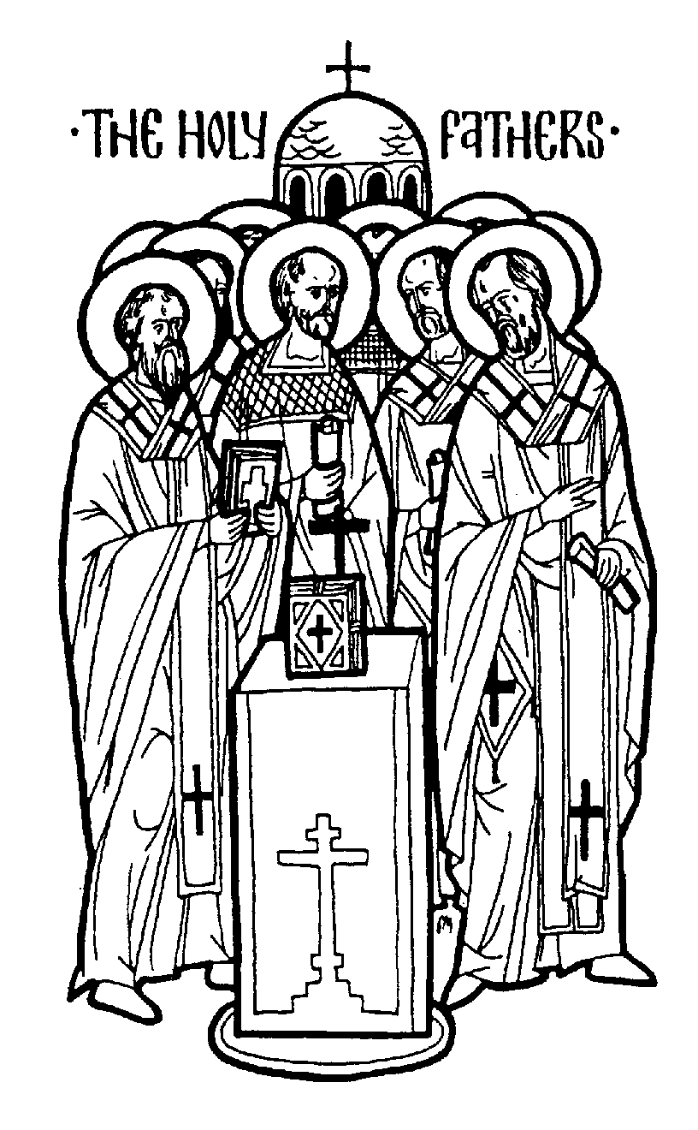
July 19, 2020
Sunday of the Holy Fathers of Fourth Ecumenical Council
Venerable Macrina, sister of Basil the Great; Venerable Dios of Antioch; Theodore, archbishop of Edessa; uncovering of the relics of Venerable Seraphim of Sarov;
Holy Stephen Lazarevic, Serbian Prince and
Holy Militsa his mother
HYMNS AFTER THE LITTLE ENTRANCE
All: Troparion of the Resurrection the Fifth Tone: Let us believers praise and worship the Word; coeternal with the Father and the Spirit, born of the Virgin for our salvation. For, He took pleasure in ascending the Cross in the flesh to suffer death; and to raise the dead by His glorious Resurrection.
Troparion of the Holy Fathers in the Eighth Tone Thou, O Christ, art our God of exceeding praise Who didst establish our Holy Fathers as luminous stars upon earth, and through them didst guide us unto the true Faith, O most merciful One, glory to Thee.
All: Troparion to St. Mark in the Fourth Tone: From thy childhood the light of truth enlightened thee, O Mark, and thou didst love the labor of Christ the Savior. Wherefore thou didst follow Peter with zeal and didst serve Paul as a fellow laborer and didst enlighten the world with thy holy Gospel.
Kontakion of the Theotokos in the Second Tone: O undisputed intercessor of Christians, the mediatrix unrejected by the Creator, turn not away from the voice of our petitions, though we be sinners. Come to us in time, who cries to thee in faith, with assistance; for thou art good. Hasten to us with intercessions, O Theotokos, who dost ever intercede for those who honor thee.
+ + + + + + + + + + + + + + + + + + + + + + + + + + + + + + + + + + + + + + + +
Prokeimenon (Psalm 31.11,1) Tone 8: Be glad in the Lord, and rejoice, O righteous. Blessed are they whose transgressions are forgiven.

Section from the Epistle of St. Paul to Titus (3:8-15)
Brethren, the saying is sure. I desire you to insist on these things, so that those who have believed in God may be careful to apply themselves to good deeds; these are excellent and profitable to men. But avoid stupid controversies, genealogies, dissensions, and quarrels over the law, for they are unprofitable and futile. As for a man who is factious, after admonishing him once or twice, have nothing more to do with him, knowing that such a person is perverted and sinful; he is self-condemned.
When I send Artemas or Tychicus to you, do your best to come to me at Nicopolis, for I have decided to spend the winter there. Do your best to speed Zenas the lawyer and Apollos on their way; see that they lack nothing. And let our people learn to apply themselves to good deeds, so as to help cases of urgent need, and not to be unfruitful.
All who are with me send greetings to you. Greet those who love us in the faith. Grace be with you all.
Alleluia Verse (Psalm 43:1,7) O God, we have heard with our ears. You have saved us from those who afflict us.
The Reading from the Holy Gospel according to St. Matthew (5:14-19)
The Lord said to his disciples, "You are the light of the world. A city that is set on a hill cannot be hid. Nor do men light a lamp and put it under a bushel, but on a stand, and it gives light to all in the house. Let your light so shine before men, that they may see your good works and give glory to your Father who is in heaven.
"Think not that I have come to abolish the law and the prophets; I have come not to abolish them but to fulfill them. For truly, I say to you, till heaven and earth pass away, not an iota, not a dot, will pass from the law until all is accomplished. Whoever then relaxes one of the least of these commandments and teaches men so, shall be called least in the kingdom of heaven; but he who does them and teaches them shall be called great in the kingdom of heaven. Amen.”
+ + + + + + + + + + + + + + + + + + + + + + + + + + + + + + + + + + + + + + + +
Holy oblations are given today by Michael & Charlotte Khoury for the souls of Charlotte’s mom Amineh departed this life 13 years, her brother in law Nicholas passed this life 1 year and for the health and salvation of their family, by Juliana, Adella, Emile, & Michael Tannous for David on his birthday, and by Donna Laffoon and family for the soul of her mother Ruth Conn passed away last Thursday, Memory Eternal!

Until further notice, there is no Coffee Hour.

Please remember in your prayers: Eleanor Wackeen, Jamal El-Sayegh, Francois & Maureen Maatouk, Tarek Fakhouri, Adele Bahbah, Paul Qaqundah, Theresa Joubran, Gloria Mamey and the suffering people of Syria, Iraq, Lebanon, Egypt, Libya, Ethiopia, Somalia, Palestine, Venezuela, Ukraine, and all people afflicted by violence and disease, especially those affected by the Coronavirus.
+ + + + + + + + + + + + + + + + + + + + + + + + + + + + + + + + + + + + + + + +
Good Samaritan Fund
Several years ago, St. Mark Church established a fund for assisting those in need, both within our parish and in the general community. From time to time we ask for contributions to the Good Samaritan Fund, and this is one of those times. If you are in need of assistance or you are aware of someone in our parish that needs financial assistance, please speak with Fr. Michael.

Today
Please remember that even in the midst of this difficult period, the expenses of the parish continue. It is important that we send in our donations and pledges via U.S. mail, or if you prefer to pay by credit card call the Church Office to set this up. We are working to keep our expenditures as low as possible until things return to a more normal state.
This Week
Wednesday July 15, 6:00 p.m. Vespers
Saturday July 18, 4:00 p.m. Vespers
Quote from the Saints
The science of sciences and the art of arts is the mastery of evil thoughts. The best way to master them is to see with spiritual vision the fantasy in which the demonic provocation is concealed and to protect the mind from it. It is just the same as the way in which we protect our bodily eyes, looking sharply about us and doing all we can to prevent anything, however small, from striking them.
St. Hesychios the Priest, On Watchfulness and Holiness

Macrina the Righteous, sister of St. Basil (July 19)
Saint Macrina, the elder sister of Saints Basil the Great and Gregory of Nyssa, was sought after by many as a bride because of her beauty, wisdom, and illustrious birth, and in tender youth was espoused by her parents to a bridegroom of fitting nobility. When her betrothed died, Macrina refused any other suitors, and devoted herself to a life of virginity, asceticism, and prayer. When her brother Basil returned from a brilliant career in the best schools of Constantinople and Athens, puffed up with not a little youthful pride-for knowledge puffeth up-it was the ardent admonitions and holy example of his blessed sister that persuaded him to turn from seeking worldly glory to the service of God. Saint Macrina founded a convent, where she ended her earthly life in the year 379, and was buried by her brother Gregory, who wrote a moving account of her last days and his grief at seeing such a light pass out of the world.
Regarding Church Attendance
On May 25, Gov. Newsome announced relaxed guidelines for religious gatherings in the State of California. The guidelines specify that churches, synagogues, mosques, etc. may now gather for services with a limit of 25% of capacity, or 100 attendees whichever is less.
Based on the maximum number of people allowed in our sanctuary (324), we are now allowed up to 81 attendees.
We now are enabling parish members to sign up for purposes of attending Sunday Divine Liturgy. There is a limited total number of attendees (60). To sign up, please go to https://www.signupgenius.com/go/904044CABAB29A4FF2-sunday
Every Sunday our Choir Director Barbara Scholl will ask a rotating number of singers to also be present.
Holy Services will continue being live-streamed at https://livestream.com/accounts/13863088/events/9076624?t=1586211820473
We are implementing this partial re-opening using the guidelines from the State of California and from our Metropolitan. These are summarized below. Please read these guidelines carefully and follow them.
We will continue to live stream all services until we all can be together again. For those attending services, please work diligently to be at church on time. It is a gift to be able to come together again so let’s start with “Blessed is the Kingdom” at 10 AM. You are also welcome to join us for Matins at 8:45 AM.

There is a great deal of joy in bringing our community back together again even though we are still doing this slowly.
All attendees must practice self-distancing, excepting those who live in the same household (no less than 6 ft. separation). Every other row of seats will be “blocked off” to facilitate distancing. Ushers may ask you to move if necessary to maintain prudent distancing.

The wearing of protective masks is highly recommended (young children excepted). Choir members will not be wearing masks, but will practice rigorous distancing).
If you have symptoms of illness, please stay home. These symptoms include:
Fever or chills
Cough
Shortness of breath or difficulty breathing
Fatigue
Muscle or body aches
Headache
New loss of taste or smell
Sore throat
Congestion or runny nose
Nausea or vomiting
Diarrhea
People with serious underlying conditions and the elderly should stay home. These people can schedule Confession and/or reception of Holy Communion by appointment. If you have been exposed to someone with COVID-19, you should not participate in holy services for 14 days.
The “stay at home” order went into effect in mid-Lent. Holy Confession therefore, is overdue for many. These can be scheduled with Fr. Michael on Wednesday or Saturday after Vespers. For the time being Confessions will not be heard on Sunday mornings. The weekly Vespers services are open to all (up to our 81 person limit).
Points of contact in the Narthex and Church will be cleaned/disinfected after each service. Hand sanitizer will be available in the Narthex (please help us by bringing your own, if possible).
Please use sanitizer or soap and water to wash your hands upon entering the church building.
Clergy will cleanse their hands periodically during holy services.
Regarding the distribution of Holy Communion, I quote from the directive of our Metropolitan, “we will continue to offer Communion according to our Tradition, but all should allow the priest to pour the Body and Blood by opening their mouths wide and not closing their lips on the spoon. If the spoon does touch the mouth of the communicant, it should be wiped on the kalima [communion cloth].”
When lining up for Holy Communion, please maintain 6 ft. distancing
Antidoron [holy bread] will be handed out by the priest, or an altar server wearing a plastic glove.
Collection trays will not be passed as usual. Instead one tray in the Narthex will be designated for collections.
The latest medical evidence tells us that COVID-19 is mainly spread via “respiratory droplets produced when an infected person coughs or sneezes. These droplets can land in the mouths or noses of people who are nearby or possibly be inhaled into the lungs. Spread is more likely when people are in close contact with one another (within about 6 feet).” (CDC website).
Gathering to celebrate the Lord’s Day is essential to Christian life. At the same time the last thing we want to see happen is for our gatherings to enable any serious illness. This is why the practices listed above are necessary.
Please continue to pray that our decisions and actions in the process of re-opening our church (and indeed our society) are guided by God’s wisdom. No plan is perfect so I apologize for any inconveniences ours may cause. If you have questions, please contact me via email (frmlaffoon@gmail.com) or call the Church Office (949-851-8933)

