St. Mark Antiochian Orthodox Church
Antiochian Orthodox Christian Archdiocese, Diocese of the West
17840 Sky Park Circle, Irvine CA 92614 (949) 851-8933
Church Office Hours: M-F, 10:00 am – 3:30 pm
Website: www.st-mark-church.org

Archpriest Michael Laffoon, Priest Patrick Irish

Protodeacon George Moubayed, Dn. Nicholas Mamey, Sub Deacon Athanasius Fakhouri

Choir Director Barbara Scholl

Chanters: Jacob Bahbah, Mark Ellis, Theresa Joubran,

Karim Youssef
Teen Advisor: Fatin Fakhouri
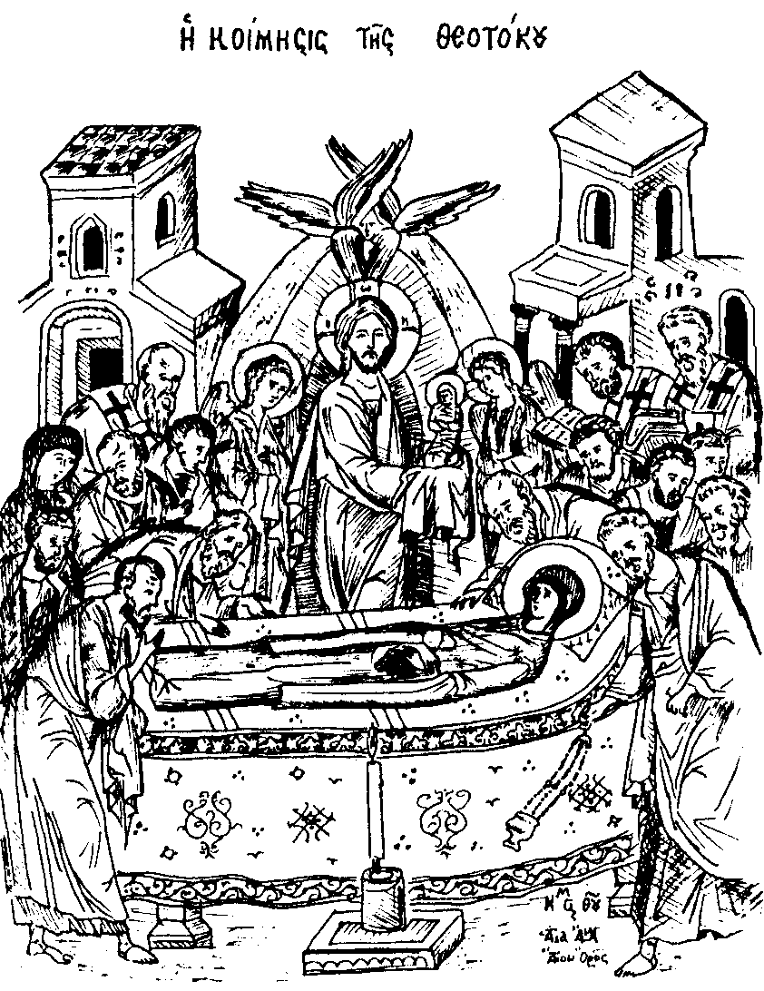

August 23, 2020
11th Sunday After Pentecost
Leave-taking of the Dormition of the Theotokos
Martyr Lupus, servant of the Great-Martyr Demetrios;
Hieromartyr Irenaios, bishop of Lyons; Venerable Nicholas and Dionysios of Olympus
DURING THE LITTLE ENTRANCE
Troparion of the Dormition in the First Tone: In giving birth, you preserved your virginity. In falling-asleep you did not forsake the world, O Theotokos! You were translated to life, O Mother of Life, and by your prayers you deliver our souls from death.
HYMNS AFTER THE LITTLE ENTRANCE
Troparion of the Resurrection in the Second Tone: When Thou didst submit Thyself unto death, O Thou deathless and immortal one, then Thou didst destroy Hell with Thy Godly power, and when Thou didst raise the dead from beneath the earth, all the powers of heaven did cry aloud unto Thee, O Christ Thou giver of Life glory to Thee.
Troparion of the Dormition in the First Tone (See above)
All: Troparion to St. Mark in the Fourth Tone: From thy childhood the light of truth enlightened thee, O Mark, and thou didst love the labor of Christ the Savior. Wherefore thou didst follow Peter with zeal and didst serve Paul as a fellow laborer and didst enlighten the world with thy holy Gospel.
Kontakion of the Dormition in the Second Tone: Verily, the Theotokos, who is ever watchful in intercessions, who is never rejected, neither tomb nor death could control. But being the Mother of Life, he who dwelt in her ever-virgin womb did translate her to life.
+ + + + + + + + + + + + + + + + + + + + + + + + + + + + + + + + + + + + + + + +
Prokeimenon (Psalm 117:14,18) The Lord is my strength and my song. The Lord has chastened me sorely.
Section from St. Paul's First Letter to the Corinthians (9:2-12)
Brethren, you are the seal of my apostleship in the Lord. This is my defense to those who would examine me. Do we not have the right to our food and drink? Do we not have the right to be accompanied by a wife, as the other apostles and the brothers of the Lord and Cephas? Or is it only Barnabas and I who have no right to refrain from working for a living? Who serves as a soldier at his own expense? Who plants a vineyard without eating any of its fruit? Who tends a flock without getting some of the milk?
Do I say this on human authority? Does not the law say the same? For it is written in the Law of Moses, "You shall not muzzle an ox when it is treading out the grain." Is it for oxen that God is concerned? Does he not speak entirely for our sake? It was written for our sake, because the plowman should plow in hope and the thresher thresh in hope of a share in the crop. If we have sown spiritual good among you, is it too much if we reap your material benefits? If others share this rightful claim upon you, do not we still more? Nevertheless, we have not made use of this right, but we endure anything rather than put an obstacle in the way of the gospel of Christ
Alleluia Verses (Psalm 19:1,9) May the Lord hear you in the day of your trouble. O Lord, save the king, and hear us when we call upon you.
The Reading from the Holy Gospel according to St. Matthew (18:23-35) The Lord spoke this parable: "Therefore the kingdom of heaven may be compared to a king who wished to settle accounts with his servants. When he began the reckoning, one was brought to him who owed him ten thousand talents; and as he could not pay, his lord ordered him to be sold, with his wife and children and all that he had, and payment to be made. So the servant fell on his knees, imploring him, 'Lord, have patience with me, and I will pay you everything.' And out of pity for him the lord of that servant released him and forgave him the debt. But that same servant, as he went out, came upon one of his fellow servants who owed him a hundred denarii; and seizing him by the throat he said, 'Pay what you owe.' So his fellow servant fell down and besought him, 'Have patience with me, and I will pay you.' He refused and went and put him in prison till he should pay the debt. When his fellow servants saw what had taken place, they were greatly distressed, and they went and reported to their lord all that had taken place. Then his lord summoned him and said to him, 'You wicked servant! I forgave you all that debt because you besought me; and should not you have had mercy on your fellow servant, as I had mercy on you?' And in anger his lord delivered him to the jailers, till he should pay all his debt. So also my heavenly Father will do to every one of you, if you do not forgive your brother from your heart.
+ + + + + + + + + + + + + + + + + + + + + + + + + + + + + + + + + + + + + + + +
Holy oblations are given today by Spir and Marwan Dabit and his siblings for the soul of his departed mother Laurette Dabit (5 years) and for the health and salvation of their family.

Please note that we can donate for disaster relief for Lebanon via the Archdiocese at https://antiochian.networkforgood.com/projects/106179-financial-aid-following-beirut-explosion

Until further notice, there is no Coffee Hour.

Please remember in your prayers: Eleanor Wackeen, Yuri Sidorenko, Jamal El-Sayegh, Tarek Fakhouri, Adele Bahbah, Paul Qaqundah, Theresa Joubran, Gloria Mamey and the suffering people of Syria, Iraq, Lebanon, Egypt, Libya, Ethiopia, Somalia, Palestine, Venezuela, Ukraine, and all people afflicted by violence and disease, especially those affected by the Coronavirus.
+ + + + + + + + + + + + + + + + + + + + + + + + + + + + + + + + + + + + + + + +
Good Samaritan Fund
Several years ago, St. Mark Church established a fund for assisting those in need, both within our parish and in the general community. From time to time we ask for contributions to the Good Samaritan Fund, and this is one of those times. If you are in need of assistance or you are aware of someone in our parish that needs financial assistance, please speak with Fr. Michael.

Today
Note: As of August 7, Lydia Wakileh is no longer working in our church office. We thank her for her 24 years of dedicated service to St. Mark Church, and when conditions allow, we hope to honor her after Sunday Liturgy with all of the parish present.

Lydia continues to be a beloved sister in our community and we ask God to bless her with every good thing.

Volunteers will take on some of the many duties she performed. If you have additions to the bulletin (e.g. Oblations, Trisagion services) please call Fr Michael at the church office number (949) 851-8933.

Please remember that even in the midst of this difficult period, the expenses of the parish continue. It is important that we send in our donations and pledges via U.S. mail, or if you prefer to pay by credit card go to our new parish web page www.st-mark-church.org and click on “Donate” We are working to keep our expenditures as low as possible until things return to a more normal state.

This Week
Wednesday Vespers 6:00 p.m.

Saturday 10:00 a.m. Divine Liturgy for Beheading of St. John the Baptist (Orthros at 9:00 a.m.). This is a strict fasting day.

Saturday Vespers 4:00 0.m.

Quote from the Saints
"True hope seeks the Kingdom of God alone and is convinced that everything earthly that is necessary for this transitory life will unfailingly be given. The heart cannot have peace until it acquires this hope." -– St. Seraphim of Sarov
Our Holy Father Irenaeus, Bishop of Lyons
The Holy Hieromartyr Irenaeus was born in Asia Minor about the year 120, and in his youth was a disciple of Saint Polycarp, Bishop of Smyrna. Saint Irenaeus was sent to Lyons in Gaul, to be a fellow labourer of Pothinus, Bishop of Lyons (celebrated June 2), who had also been a disciple Saint Polycarp. After the martyrdom of Saint Pothinus, Saint Irenaeus succeeded him as Bishop of Lyons. Besides the assaults of paganism, Irenaeus found himself compelled to do battle with many Gnostic heresies, against which he wrote his greatest work, A Refutation and Overthrow of Knowledge Falsely So Called . He was also a peace-maker within the Church. When Victor, Bishop of Rome, was prepared to excommunicate the Christians of Asia Minor for following a different tradition celebrating Pascha, Irenaeus persuaded him to moderate his zeal, and mediated peace. He made Lyons an illustrious bastion of Orthodoxy and a school of piety, and sealed his confession with martyrdom about the year 202, during the reign of Septimius Severus. He is not to be confused with Saint Irenaeus, Bishop of Sirmium, also celebrated today, who was beheaded and cast into a river in 304 under Diocletian.

Regarding Church Attendance
We have enabling parish members to sign up for purposes of attending Sunday Divine Liturgy. There is a limited total number of attendees (60). To sign up, please go to https://www.signupgenius.com/go/904044CABAB29A4FF2-sunday
Every Sunday our Choir Director Barbara Scholl will ask a rotating number of singers to also be present.

Holy Services will continue being live-streamed at https://livestream.com/accounts/13863088/events/9076624?t=1586211820473

We are implementing this partial re-opening using the guidelines from the State of California and from our Metropolitan. These are summarized below. Please read these guidelines carefully and follow them.

We will continue to live stream all services until we all can be together again. For those attending services, please work diligently to be at church on time. It is a gift to be able to come together again so let’s start with “Blessed is the Kingdom” at 10 AM. You are also welcome to join us for Matins at 8:45 AM.

There is a great deal of joy in bringing our community back together again even though we are still doing this slowly.

All attendees must practice self-distancing, excepting those who live in the same household (no less than 6 ft. separation). Every other row of seats will be “blocked off” to facilitate distancing. Ushers may ask you to move if necessary to maintain prudent distancing.

The wearing of protective masks is highly recommended (young children excepted). Choir members will not be wearing masks, but will practice rigorous distancing).

If you have symptoms of illness, please stay home. These symptoms include:
Fever or chills
Cough
Shortness of breath or difficulty breathing
Fatigue
Muscle or body aches
Headache
New loss of taste or smell
Sore throat
Congestion or runny nose
Nausea or vomiting
Diarrhea
People with serious underlying conditions and the elderly should stay home. These people can schedule Confession and/or reception of Holy Communion by appointment. If you have been exposed to someone with COVID-19, you should not participate in holy services for 14 days.

The “stay at home” order went into effect in mid-Lent. Holy Confession therefore, is overdue for many. These can be scheduled with Fr. Michael on Wednesday or Saturday after Vespers. For the time being Confessions will not be heard on Sunday mornings. The weekly Vespers services are open to all (up to our 81 person limit).
Points of contact in the Narthex and Church will be cleaned/disinfected after each service. Hand sanitizer will be available in the Narthex (please help us by bringing your own, if possible).
Please use sanitizer or soap and water to wash your hands upon entering the church building.
Clergy will cleanse their hands periodically during holy services.
Regarding the distribution of Holy Communion, I quote from the directive of our Metropolitan, “we will continue to offer Communion according to our Tradition, but all should allow the priest to pour the Body and Blood by opening their mouths wide and not closing their lips on the spoon. If the spoon does touch the mouth of the communicant, it should be wiped on the kalima [communion cloth].”
When lining up for Holy Communion, please maintain 6 ft. distancing. Antidoron [holy bread] will be handed out by the priest, or an altar server wearing a plastic glove.
Collection trays will not be passed as usual. Instead one tray in the Narthex will be designated for collections.
The latest medical evidence tells us that COVID-19 is mainly spread via “respiratory droplets produced when an infected person coughs or sneezes. These droplets can land in the mouths or noses of people who are nearby or possibly be inhaled into the lungs. Spread is more likely when people are in close contact with one another (within about 6 feet).” (CDC website).
Gathering to celebrate the Lord’s Day is essential to Christian life. At the same time the last thing we want to see happen is for our gatherings to enable any serious illness. This is why the practices listed above are necessary.
Please continue to pray that our decisions and actions in the process of re-opening our church (and indeed our society) are guided by God’s wisdom. No plan is perfect so I apologize for any inconveniences ours may cause. If you have questions, please contact me via email (frmlaffoon@gmail.com) or call the Church Office (949-851-8933)

