St. Mark Antiochian Orthodox Church
Antiochian Orthodox Christian Archdiocese, Diocese of the West
17840 Sky Park Circle, Irvine CA 92614 (949) 851-8933
Church Office Hours: M-F, 10:00 am – 3:30 pm
Website: www.st-mark-church.org

Archpriest Michael Laffoon, Priest Patrick Irish

Protodeacon George Moubayed, Dn. Nicholas Mamey, Sub Deacon Athanasius Fakhouri

Choir Director Barbara Scholl

Chanters: Jacob Bahbah, Mark Ellis, Theresa Joubran,

Karim Youssef

Church Office Secretary: Lydia Wakileh
Teen Advisor: Fatin Fakhouri

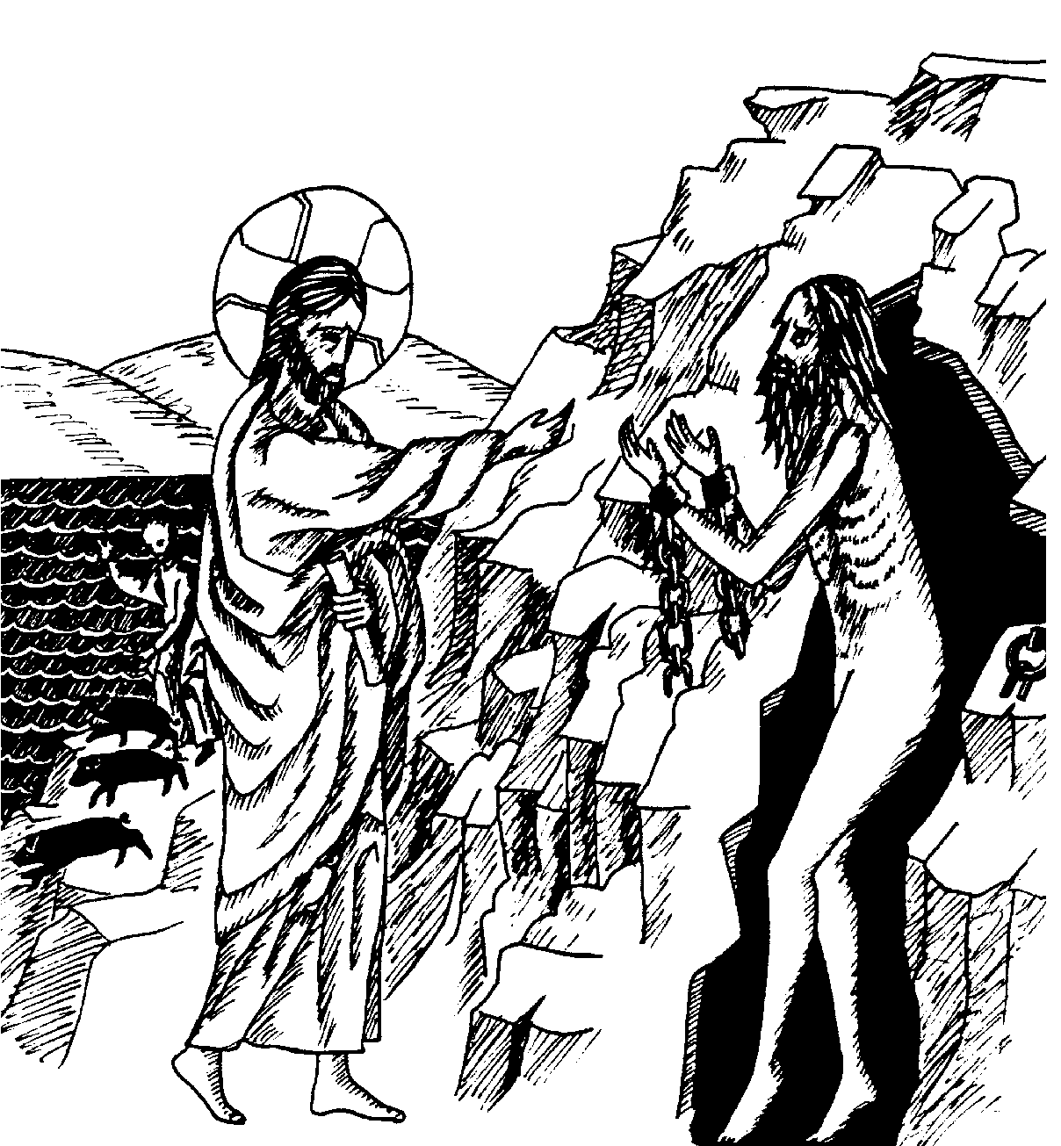
July 12, 2020
Fifth Sunday After Pentecost
Holy Martyrs Proclus and Hilary of Ancyra; Veronica, the woman with the issue of blood who was healed by our Lord; Venerable Father Paisios
the New of Athos
HYMNS AFTER THE LITTLE ENTRANCE
All: Troparion of the Resurrection the Fourth Tone: Having learned the joyful message of the Resurrection from the angel the women disciples of theLord cast from them their parental condemnation. And proudly broke the news to the Disciples, saying: Death hath been spoiled; Christ God is risen, granting the world Great Mercy.
All: Troparion to St. Mark in the Fourth Tone: From thy childhood the light of truth enlightened thee, O Mark, and thou didst love the labor of Christ the Savior. Wherefore thou didst follow Peter with zeal and didst serve Paul as a fellow laborer and didst enlighten the world with thy holy Gospel.
Kontakion of the Theotokos in the Second Tone: O undisputed intercessor of Christians, the mediatrix unrejected by the Creator, turn not away from the voice of our petitions, though we be sinners. Come to us in time, who cries to thee in faith, with assistance; for thou art good. Hasten to us with intercessions, O Theotokos, who dost ever intercede for those who honor thee.
+ + + + + + + + + + + + + + + + + + + + + + + + + + + + + + + + + + + + + + + +
Prokeimenon (Psalm103.24, 1) Tone 4: O Lord, how magnificent are your works. You have made all things in wisdom. Bless the Lord, O my soul.
Reading from St. Paul’s Letter to the Romans (10:1-0)
Brethren, my heart's desire and prayer to God for them is that they may be saved. I bear them witness that they have a zeal for God, but it is not enlightened. For, being ignorant of the righteousness that comes from God, and seeking to establish their own, they did not submit to God's righteousness. For Christ is the end of the law, that every one who has faith may be justified.
Moses writes that the man who practices the righteousness which is based on the law shall live by it. But the righteousness based on faith says, Do not say in your heart, "Who will ascend into heaven?" (That is, to bring Christ down) or "Who will descend into the abyss?" (That is, to bring Christ up from the dead). But what does it say? The word is near you, on your lips and in your heart (that is, the word of faith, which we preach); because, if you confess with your lips that Jesus is Lord and believe in your heart that God raised him from the dead, you will be saved. For man believes with his heart and so is justified, and he confesses with his lips and so is saved.
Alleluia Verses (Psalms 44.4, 7) Tone 4: Draw your bow and prosper and reign, for the cause of truth and meekness and righteousness. You have loved righteousness and hated wickedness.
Reading from the gospel according to St Matthew (8:28-9:1)
At that time, when Jesus came to the country of the Gergesenes, two demoniacs met him, coming out of the tombs, so fierce that no one could pass that way. And behold, they cried out, "What have you to do with us, O Son of God? Have you come here to torment us before the time?" Now a herd of many swine was feeding at some distance from them. And the demons begged him, "If you cast us out, send us away into the herd of swine." And he said to them, "Go." So they came out and went into the swine; and behold, the whole herd rushed down the steep bank into the sea, and perished in the waters. The herdsmen fled, and going into the city they told everything, and what had happened to the demoniacs. And behold, all the city came out to meet Jesus; and when they saw him, they begged him to leave their neighborhood.
And getting into a boat he crossed over and came to his own city.
+ + + + + + + + + + + + + + + + + + + + + + + + + + + + + + + + + + + + + + + +
Holy oblations are given today by Ibrahim, Lydia, Charlie, Michelle, and Michael Wakileh for the health and salvation of the family and for Christopher on the occasion of his birthday (7/13) and Esperance Hadshiti birthday (7/15), and by Austin, Saeda, Anthony and Alex and the entire Turk family for the continued good health and salvation of Stephanie and Brittany on the occasion of their birthdays this week.
Until further notice, there is no Coffee Hour.

Please remember in your prayers: Eleanor Wackeen, Jamal El-Sayegh, Francois & Maureen Maatouk, Tarek Fakhouri, Adele Bahbah, Paul Qaqundah, Theresa Joubran, Gloria Mamey and the suffering people of Syria, Iraq, Lebanon, Egypt, Libya, Ethiopia, Somalia, Palestine, Venezuela, Ukraine, and all people afflicted by violence and disease, especially those affected by the Coronavirus.
+ + + + + + + + + + + + + + + + + + + + + + + + + + + + + + + + + + + + + + + +
Good Samaritan Fund
Several years ago, St. Mark Church established a fund for assisting those in need, both within our parish and in the general community. From time to time we ask for contributions to the Good Samaritan Fund, and this is one of those times. If you are in need of assistance or you are aware of someone in our parish that needs financial assistance, please speak with Fr. Michael.

Today
Please remember that even in the midst of this difficult period, the expenses of the parish continue. It is important that we send in our donations and pledges via U.S. mail, or if you prefer to pay by credit card call the Church Office to set this up. We are working to keep our expenditures as low as possible until things return to a more normal state.
This Week
Wednesday July 15, 6:00 p.m. Vespers
Saturday July 18, 4:00 p.m. Vespers
Quote from the Saints
One must make the sign of the cross on oneself, either with the name of the Holy Trinity, saying “In the name of the Father and of the Son, and of the Holy Spirit,” or with the name of One of the Trinity, Who became incarnate for our sake and was voluntarily crucified, saying, “Lord Jesus Christ, Son of God, have mercy on me a sinner.” St. Ambrose of Optina
Holy Martyrs Proklos and Hilarion of Ancyra (July 12)
These Martyrs contested in Ancyra in 106, during the reign of the Emperor Trajan. Saint Proclos was seized as a Christian and, confessing his faith, was burned on his sides and belly, was hung upon a beam with heavy stones tied to his feet, and finally was taken away to be shot with arrows. As he was being led forth, his nephew Hilary encountered him and greeted him, and was himself seized. After his uncle had been slain with arrows, Hilary, because he would not deny Christ, was tormented, then beheaded.

Regarding Church Attendance
On May 25, Gov. Newsome announced relaxed guidelines for religious gatherings in the State of California. The guidelines specify that churches, synagogues, mosques, etc. may now gather for services with a limit of 25% of capacity, or 100 attendees whichever is less.
Based on the maximum number of people allowed in our sanctuary (324), we are now allowed up to 81 attendees.
We now are enabling parish members to sign up for purposes of attending Sunday Divine Liturgy. There is a limited total number of attendees (60). To sign up, please go to https://www.signupgenius.com/go/904044CABAB29A4FF2-sunday
Every Sunday our Choir Director Barbara Scholl will ask a rotating number of singers to also be present.
Holy Services will continue being live-streamed at https://livestream.com/accounts/13863088/events/9076624?t=1586211820473
We are implementing this partial re-opening using the guidelines from the State of California and from our Metropolitan. These are summarized below. Please read these guidelines carefully and follow them.
We will continue to live stream all services until we all can be together again. For those attending services, please work diligently to be at church on time. It is a gift to be able to come together again so let’s start with “Blessed is the Kingdom” at 10 AM. You are also welcome to join us for Matins at 8:45 AM.

There is a great deal of joy in bringing our community back together again even though we are still doing this slowly.
All attendees must practice self-distancing, excepting those who live in the same household (no less than 6 ft. separation). Every other row of seats will be “blocked off” to facilitate distancing. Ushers may ask you to move if necessary to maintain prudent distancing.

The wearing of protective masks is highly recommended (young children excepted). Choir members will not be wearing masks, but will practice rigorous distancing).
If you have symptoms of illness, please stay home. These symptoms include:
Fever or chills
Cough
Shortness of breath or difficulty breathing
Fatigue
Muscle or body aches
Headache
New loss of taste or smell
Sore throat
Congestion or runny nose
Nausea or vomiting
Diarrhea
People with serious underlying conditions and the elderly should stay home. These people can schedule Confession and/or reception of Holy Communion by appointment. If you have been exposed to someone with COVID-19, you should not participate in holy services for 14 days.
The “stay at home” order went into effect in mid-Lent. Holy Confession therefore, is overdue for many. These can be scheduled with Fr. Michael on Wednesday or Saturday after Vespers. For the time being Confessions will not be heard on Sunday mornings. The weekly Vespers services are open to all (up to our 81 person limit).
Points of contact in the Narthex and Church will be cleaned/disinfected after each service. Hand sanitizer will be available in the Narthex (please help us by bringing your own, if possible).
Please use sanitizer or soap and water to wash your hands upon entering the church building.
Clergy will cleanse their hands periodically during holy services.
Regarding the distribution of Holy Communion, I quote from the directive of our Metropolitan, “we will continue to offer Communion according to our Tradition, but all should allow the priest to pour the Body and Blood by opening their mouths wide and not closing their lips on the spoon. If the spoon does touch the mouth of the communicant, it should be wiped on the kalima [communion cloth].”
When lining up for Holy Communion, please maintain 6 ft. distancing
Antidoron [holy bread] will be handed out by the priest, or an altar server wearing a plastic glove.
Collection trays will not be passed as usual. Instead one tray in the Narthex will be designated for collections.
The latest medical evidence tells us that COVID-19 is mainly spread via “respiratory droplets produced when an infected person coughs or sneezes. These droplets can land in the mouths or noses of people who are nearby or possibly be inhaled into the lungs. Spread is more likely when people are in close contact with one another (within about 6 feet).” (CDC website).
Gathering to celebrate the Lord’s Day is essential to Christian life. At the same time the last thing we want to see happen is for our gatherings to enable any serious illness. This is why the practices listed above are necessary.
Please continue to pray that our decisions and actions in the process of re-opening our church (and indeed our society) are guided by God’s wisdom. No plan is perfect so I apologize for any inconveniences ours may cause. If you have questions, please contact me via email (frmlaffoon@gmail.com) or call the Church Office (949-851-8933)

