St. Mark Antiochian Orthodox Church
Antiochian Orthodox Christian Archdiocese, Diocese of the West
17840 Sky Park Circle, Irvine CA 92614 (949) 851-8933
Church Office Hours: M-F, 10:00 am – 3:30 pm
Website: www.st-mark-church.org

Archpriest Michael Laffoon, Priest Patrick Irish

Protodeacon George Moubayed, Dn. Nicholas Mamey, Sub Deacon Athanasius Fakhouri

Choir Director Barbara Scholl

Chanters: Jacob Bahbah, Mark Ellis, Theresa Joubran,

Karim Youssef

Church Office Secretary: Lydia Wakileh
Teen Advisor: Fatin Fakhouri
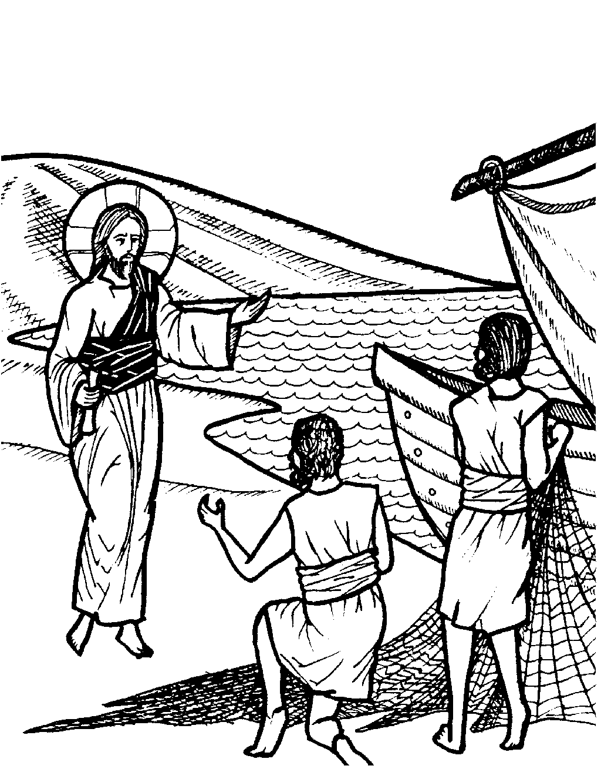
June 28, 2020
Third Sunday After Pentecost
Recovery of the relics of Cyrus & John the Unmercenaries; Martyr Papios; Paul the Physician of Corinth; Venerable Moses the anchorite; Venerable Sergios and Herman, wonderworking abbots of Valaam

HYMNS AFTER THE LITTLE ENTRANCE
All: Troparion of the Resurrection the Second Tone: When Thou didst submit Thyself unto death, O Thou deathless and Immortal One. Then Thou didst destroy hell with Thy Godly power; and when Thou didst raise the dead from beneath the earth, all the powers of Heaven did cry aloud unto Thee: O Christ God, Thou Giver of life, glory to Thee.
All: Troparion to St. Mark in the Fourth Tone: From thy childhood the light of truth enlightened thee, O Mark, and thou didst love the labor of Christ the Savior. Wherefore thou didst follow Peter with zeal and didst serve Paul as a fellow laborer and didst enlighten the world with thy holy Gospel.
Kontakion of the Theotokos in the Second Tone: O undisputed intercessor of Christians, the mediatrix unrejected by the Creator, turn not away from the voice of our petitions, though we be sinners. Come to us in time, who cries to thee in faith, with assistance; for thou art good. Hasten to us with intercessions, O Theotokos, who dost ever intercede for those who honor thee.
+ + + + + + + + + + + + + + + + + + + + + + + + + + + + + + + + + + + + + + + +
Prokeimenon (Psalm 117:14, 18) The Lord is my strength and my song. The Lord has chastened me sorely.
Reading from St. Paul's Letter to the Romans (5:1-11)
Brethren, since we are justified by faith, we have peace with God through our Lord Jesus Christ. Through him we have obtained access to this grace in which we stand, and we rejoice in our hope of sharing the glory of God. More than that, we rejoice in our sufferings, knowing that suffering produces endurance, and endurance produces character, and character produces hope, and hope does not disappoint us, because God's love has been poured into our hearts through the Holy Spirit which has been given to us.
While we were still weak, at the right time Christ died for the ungodly. Why, one will hardly die for a righteous man - though perhaps for a good man one will dare even to die. But God shows his love for us in that while we were yet sinners Christ died for us. Since, therefore, we are now justified by his blood, much more shall we be saved by him from the wrath of God. For if while we were enemies we were reconciled to God by the death of his Son, much more, now that we are reconciled, shall we be saved by his life. Not only so, but we also rejoice in God through our Lord Jesus Christ, through whom we have now received our reconciliation.
Alleluia Verses (Psalm 19:1, 9) May the Lord hear you in the day of trouble. O Lord, save the king, and hear us when we call upon you.
The Reading from the Holy Gospel according to St. Matthew (6:22-33)
The Lord said, "The eye is the lamp of the body. So, if your eye is sound, your whole body will be full of light; but if your eye is not sound, your whole body will be full of darkness. If then the light in you is darkness, how great is the darkness! "
No one can serve two masters; for either he will hate the one and love the other, or he will be devoted to the one and despise the other. You cannot serve God and mammon.
"Therefore I tell you, do not be anxious about your life, what you shall eat or what you shall drink, nor about your body, what you shall put on. Is not life more than food, and the body more than clothing? Look at the birds of the air: they neither sow nor reap nor gather into barns, and yet your heavenly Father feeds them. Are you not of more value than they? And which of you by being anxious can add one cubit to his span of life? And why are you anxious about clothing? Consider the lilies of the field, how they grow; they neither toil nor spin; yet I tell you, even Solomon in all his glory was not arrayed like one of these. But if God so clothes the grass of the field, which today is alive and tomorrow is thrown into the oven, will he not much more clothe you, O men of little faith? Therefore do not be anxious, saying, 'What shall we eat?' or 'What shall we drink?' or 'What shall we wear?' For the Gentiles seek all these things; and your heavenly Father knows that you need them all. But seek first his kingdom and his righteousness, and all these things shall be yours as well.

Holy oblations are given today by the Wakileh, Bahbah, Turk & Hadshity families for the health and salvation of their mother Adele Bahbah on her birthday 6/25, and Joe Bahbah 6/29, and for the health and salvation of their families.

Until further notice, Coffee Hour is cancelled.
+ + + + + + + + + + + + + + + + + + + + + + + + + + + + + + + + + + + + + + + +
Please remember in your prayers: Eleanor Wackeen, Jamal El-Sayegh, Francois & Maureen Maatouk, Tarek Fakhouri, Adele Bahbah, Paul Qaqundah, Theresa Joubran, and the suffering people of Syria, Iraq, Lebanon, Egypt, Libya, Ethiopia, Somalia, Palestine, Venezuela, Ukraine, and all people afflicted by violence and disease, especially those affected by the Coronavirus.
+ + + + + + + + + + + + + + + + + + + + + + + + + + + + + + + + + + + + + + + +
Good Samaritan Fund
Several years ago, St. Mark Church established a fund for assisting those in need, both within our parish and in the general community. From time to time we ask for contributions to the Good Samaritan Fund, and this is one of those times. If you are in need of assistance or you are aware of someone in our parish that needs financial assistance, please speak with Fr. Michael.

Today
Apostles fast began on June 15. The Fast of the Holy Apostles is not as strict as the Fasts of Pascha and the Nativity of Christ; rather it is more lenient in its duration and rules. The current rules of fasting, during the Apostles' Fast, were established first for the monks of the Monastery of the Kiev Caves by Metropolitan George of Kiev (1069-1072). These rules are still practiced today amongst most Orthodox Christians with minor variations, depending on the jurisdiction.
The rules are:
1- Red meat, poultry, and dairy products are not allowed during the entire fasting period in all weekdays.
2- Fish, wine, and oil are allowed on all days except on Mondyas, Wednesdays and Fridays
Please remember that even in the midst of this difficult period, the expenses of the parish continue. It is important that we send in our donations and pledges via U.S. mail, or if you prefer to pay by credit card call the Church Office to set this up. We are working to keep our expenditures as low as possible until things return to a more normal state.
This Week
Monday June 29, 10:00 a.m. Divine Liturgy, Feast of St. Peter and Paul

Wednesday July 1, 6:00 p.m. Vespers

Finding of the Relics of Cyrus and John the Unmercenaries
These Saints lived during the years of Diocletian. Saint Cyrus was from Alexandria, and Saint John was from Edessa of Mesopotamia. Because of the persecution of that time, Cyrus fled to the Gulf of Arabia, where there was a small community of monks. John, who was a soldier, heard of Cyrus' fame and came to join him. Henceforth, they passed their life working every virtue, and healing every illness and disease freely by the grace of Christ; hence their title of "Unmercenaries." They heard that a certain woman, named Athanasia, had been apprehended together with her three daughters, Theodora, Theoctiste, and Eudoxia, and taken to the tribunal for their confession of the Faith. Fearing lest the tender young maidens be terrified by the torments and renounce Christ, they went to strengthen them in their contest in martyrdom; therefore they too were seized. After Cyrus and John and those sacred women had been greatly tormented, all were beheaded in the year 292. Their tomb became a renowned shrine in Egypt, and a place of universal pilgrimage. It was found in the area of the modern day resort near Alexandria named Abu Kyr.

Regarding Church Attendance
On May 25, Gov. Newsome announced relaxed guidelines for religious gatherings in the State of California. The guidelines specify that churches, synagogues, mosques, etc. may now gather for services with a limit of 25% of capacity, or 100 attendees whichever is less.
Based on the maximum number of people allowed in our sanctuary (324), we are now allowed up to 81 attendees.
This will be a partial re-opening of our services. This requires some kind of system to allow a larger number of people to start coming to holy services without going over our limit and allowing everyone a chance to attend, even though it can’t all be on the same day.
We now are enabling parish members to sign up for purposes of attending Sunday Divine Liturgy. There is a limited total number of attendees (60). To sign up, please go to https://www.signupgenius.com/go/904044CABAB29A4FF2-sunday
Every Sunday our Choir Director Barbara Scholl will ask a rotating number of singers to also be present.
Holy Services will continue being live-streamed at https://livestream.com/accounts/13863088/events/9076624?t=1586211820473
We are implementing this partial re-opening using the guidelines from the State of California and from our Metropolitan. These are summarized below. Please read these guidelines carefully and follow them.
We will continue to live stream all services until we all can be together again. For those attending services, please work diligently to be at church on time. It is a gift to be able to come together again so let’s start with “Blessed is the Kingdom” at 10 AM. You are also welcome to join us for Matins at 8:45 AM.

There is a great deal of joy in bringing our community back together again even though we are still doing this slowly.

All attendees must practice self-distancing, excepting those who live in the same household (no less than 6 ft. separation). Every other row of seats will be “blocked off” to facilitate distancing. Ushers may ask you to move if necessary to maintain prudent distancing.
The wearing of protective masks is highly recommended (young children excepted). Choir members will not be wearing masks, but will practice rigorous distancing).

If you have symptoms of illness, please stay home. These symptoms include:
Fever or chills
Cough
Shortness of breath or difficulty breathing
Fatigue
Muscle or body aches
Headache
New loss of taste or smell
Sore throat
Congestion or runny nose
Nausea or vomiting
Diarrhea

People with serious underlying conditions and the elderly should stay home. These people can schedule Confession and/or reception of Holy Communion by appointment. If you have been exposed to someone with COVID-19, you should not participate in holy services for 14 days.

The “stay at home” order went into effect in mid-Lent. Holy Confession therefore, is overdue for many. These can be scheduled with Fr. Michael on Wednesday or Saturday after Vespers. For the time being Confessions will not be heard on Sunday mornings. The weekly Vespers services are open to all (up to our 81 person limit).

Points of contact in the Narthex and Church will be cleaned/disinfected after each service. Hand sanitizer will be available in the Narthex (please help us by bringing your own, if possible).
Please use sanitizer or soap and water to wash your hands upon entering the church building.
Clergy will cleanse their hands periodically during holy services.

Regarding the distribution of Holy Communion, I quote from the directive of our Metropolitan, “we will continue to offer Communion according to our Tradition, but all should allow the priest to pour the Body and Blood by opening their mouths wide and not closing their lips on the spoon. If the spoon does touch the mouth of the communicant, it should be wiped on the kalima [communion cloth].”
When lining up for Holy Communion, please maintain 6 ft. distancing
Antidoron [holy bread] will be handed out by the priest, or an altar server wearing a plastic glove.
Collection trays will not be passed as usual. Instead one tray in the Narthex will be designated for collections.
The latest medical evidence tells us that COVID-19 is mainly spread via “respiratory droplets produced when an infected person coughs or sneezes. These droplets can land in the mouths or noses of people who are nearby or possibly be inhaled into the lungs. Spread is more likely when people are in close contact with one another (within about 6 feet).” (CDC website).
Gathering to celebrate the Lord’s Day is essential to Christian life. At the same time the last thing we want to see happen is for our gatherings to enable any serious illness. This is why the practices listed above are necessary.
Please continue to pray that our decisions and actions in the process of re-opening our church (and indeed our society) are guided by God’s wisdom. No plan is perfect so I apologize for any inconveniences ours may cause. If you have questions, please contact me via email (frmlaffoon@gmail.com) or call the Church Office (949-851-8933)

